ACEbox - RFID-Based Attendance-Checking System

Josmar Baruffaldi Cristello
Illinois Institute of Technology
3201 South State Street #2825
Chicago, IL, 60616
+1 (312) 622-4751
jbaruffa@hawk.iit.edu
Bianca Canalli Zagueto
Illinois Institute of Technology
3201 South State Street #2824
Chicago, IL, 60616
+1 (312) 420-4818
bcanalli@hawk.iit.edu
Javier Moreno Valdecantos
Illinois Institute of Technology
315 South Peoria Street #806D
Chicago, IL, 60607
+1 (312) 447-4411
jmorenov@hawk.iit.edu

ABSTRACT
Class attendance is used by professors and teachers to evaluate their students and to ensure they follow the development of a course as they are expected to. However, if the attendance verification process is inefficient it might bring problems to both the teacher, who spends too much time doing it, and the students, who may be wrongly evaluated. The objective of this project is to create a device designed to automate this process in a classroom. The basic idea was to achieve a more rapid, secure and precise method for this procedure, and the outcome was “ACEbox” which stands for Attendance-Checking Embedded box. This box gets each student’s data when they swipe their ID cards on it at the beginning of the class. The professor, who doesn’t need to understand the inner workings of the system, is able to later analyze the attendance data at his own discretion.
Categories and Subject Descriptors
C.3 [Special-Purpose and Application-Based Systems]: Real-time and embedded systems
General Terms
Management
Keywords
RFID reader, .csv files, Arduino mega

CONTENT

1. Introduction 1

2. Equipment/HW Components 1
3. Assembly/Schematics 2
4. Instruction manual 3
5. Device Code 4
6. Business Prototype 4
7. References 5

INTRODUCTION
This document provides the development process of an automatic attendance-verification device. We used the following components: RFID card reader, MicroSD card reader, real time clock, LCD screen, battery and Arduino Mega. The system produces an output that someone without technical training would be able to understand. As result, the only requirement needed to operate the system is a basic knowledge of Microsoft Excel.
The idea behind this project is to incorporate an innovative activity for an existent student ID card. Right now, most ID cards are required to open doors around campus; with this project it would also have the added benefit of quantifying students’ presence or absence. This would have the advantage of saving time in class (removing the need for manual attendance checking) and also supply precise statistics for evaluations. Furthermore, it is also harder to bypass the system, increasing the reliability of the data.
The process of verifying presence with our system can be summarized as follows: Our device will be inside a box beside the professor’s desk, and students will be required to scan their ID as soon as they arrive. Arduino will then compute whether they were late or arrived on time and write this information into a .csv file inside an SD card. If the professor wants to check/modify the attendance data, he can open that file on his personal computer using Microsoft Excel.

EQUIPMENT/HW COMPONENTS

RFID Reader
Conference’10, Month 1–2, 2010, City, State, Country.
Copyright 2010 ACM 1-58113-000-0/00/0010 …$15.00.

Permission to make digital or hard copies of all or part of this work for personal or classroom use is granted without fee provided that copies are not made or distributed for profit or commercial advantage and that copies bear this notice and the full citation on the first page. To copy otherwise, or republish, to post on servers or to redistribute to lists, requires prior specific permission and/or a fee.

RFID stands for radio-frequency identification. It works transferring data using electromagnetic fields, and has the purpose of electronically identifying stored information in cards or tags. The one used in our project can identify the RFID students’ ID cards, reading the necessary information up to ten centimeters away.

RFID Card
The RFID Card contains a chip and an antenna, and is passively powered by the reader/writer when placed in its range.
The card also be written and is able to store up to 1 KB of data. It also holds over 100,000 re-writes.

MicroSD Card Reader
The MicroSD card used is both readable and writable. In our project it holds a .csv file with the students’ and class’ information, as well as being written to register the presence, absence or late arrival of a student, after the information is processed.
The advantages of MicroSD over other forms of storage is mostly the best ratio between physical space and storage. We can store 4 Gigabytes of information, which is more than enough to hold information about thousands of students.

Real Time Clock
Real Time Clock, or RTC as it is also known, is also a key piece in our project. This equipment allows microcontroller keep track of time even if it is reprogrammed, what prevents future errors or accidents to influence the data collected.
The gear also has a backup battery with estimated duration of five years, which is another interesting factor since it does not demand to be changed frequently.
In our project its main function is to provide the current time and, after processing the data, making it possible to compute the student’s presence, absence or late arrival in class.

Liquid-Crystal Display
The Liquid-Crystal Display, or LCD as it is known, will be able to display up to 16 characters in each of its two lines. In our project, it will be the only visible electronic equipment with two main functions.
The first function will be to display a stand-by message, advising that the device is working and whether or not it recognized the student card. The second function consists of displaying real time and date once a student arrives in class and swipes the ID card.

Piezo Buzzer
The Piezo Buzzer works as an alarm in our case. It is able to make loud tones and beeps while still being small enough to fit with the other components.
In our project, it will have the purpose of confirming that the card was read by the RFID reader. There will be two different sounds. The first one will indicate that the card was successfully read and the information was computed and written to the file.
The second sound will beep in two situations. The first is when the student was not on the list of the class, which means that he is not supposed to be there. The second is when the student swipes his card more than fifteen minutes before or after the class ends, which means that he was either too early for the class or too late. The second situation was created to make sure that the professor will be in class by the time the students start swiping their cards; it’s a way to avoid students swiping their card and simply leaving the classroom. In addition, the professor will always be able to manually modify the files, if he considers it necessary.

Battery
While choosing the optimum battery for our device, we took into account that it is recommended to use a battery of at least 7V for Arduino Mega to work properly and prevent equipment damages. The closest widely available commercial battery that fulfills this recommendation is a 9V battery, which is the one we decided to use.

Arduino Mega
Arduino is the hub that connects all our electrical components and makes them work as expected. Not only all the equipment above is either attached or wired to it, but the code also predicts interaction between them.
This particular model of Arduino, Mega, was chosen because more memory was required to process the data. For instance, Arduino Uno only has 2 KB of SRAM memory, while Mega has 8 KB.

ASSEMBLY/SCHEMATICS
As mentioned above, all electronic equipment needs to be connected to Arduino. For assembling all components, copper wires and breadboards were used as basic elements. Here we’ll describe how each component is connected. To clarify this information we’ll use figures showing circuit diagrams.
The battery which powers the system is directly connected to Arduino. The Pins [GND, V] are respectively connected to Arduino’s [GND, VIN].

Complete connections
This figure shows the complete connections made for our project, with the exception of the RFID shield that should be over Arduino Mega.
All this circuit is fed with a 9V battery directly connected to Arduino pins [GND, VIN].
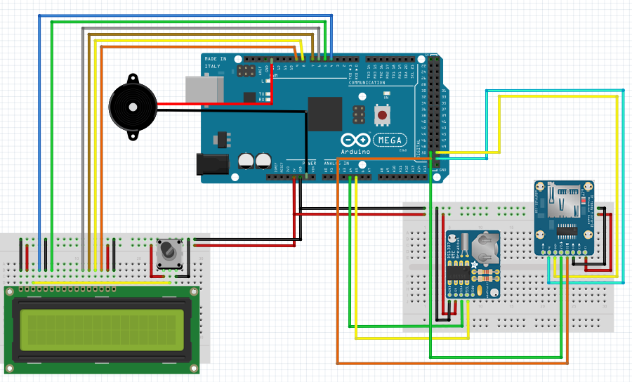

RFID shield to Arduino
The RFID reader is a shield that will be connected directly above the Arduino Mega. Using this shield makes the assembly process much simpler.

RTC/MicroSD Breadboard to Arduino
The MicroSD card reader was soldered into a breadboard with the Pins [5V, GND] respectively connected to the breadboard ‘1’ power line and ground line. The Pins [CLK, DO, DI, CS] are respectively connected to the Arduino Pins [52, 50, 53, 51].
On the same breadboard, the Real Time Clock had its Pins [5V, GND] respectively connected to the breadboard power line and ground line. The RTC also had Pins [SCL, SDA] respectively connected to Arduino Pins [A5, A4].
This breadboard is fed from Arduino pins [5V, GND].
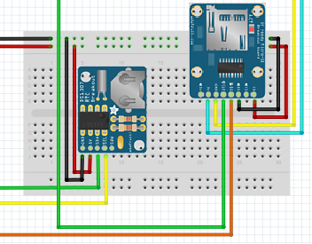

LCD Breadboard to Arduino
The LCD was soldered in a separate breadboard. It had pins [2, 15] connected to the breadboard power line and pins [1, 5, 16] connected to the breadboard ground line. Pin [3] is connected to the middle Pin of a potentiometer, which is connected to 5V and GND. Also, the LCD Pins [4, 6, 11, 12, 13, 14] are respectively connected to Arduino Pins [4, 5, 6, 7, 8, 9].
This breadboard is also fed from Arduino pins [5V, GND].
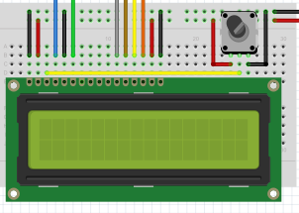

Piezo buzzer to Arduino
The Piezo Buzzer will be connected directly to Arduino pins GND and 13. We didn’t need to put it on a breadboard as it is a very simple component (it has only two ports).
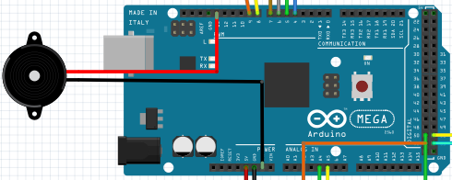

Box assembly
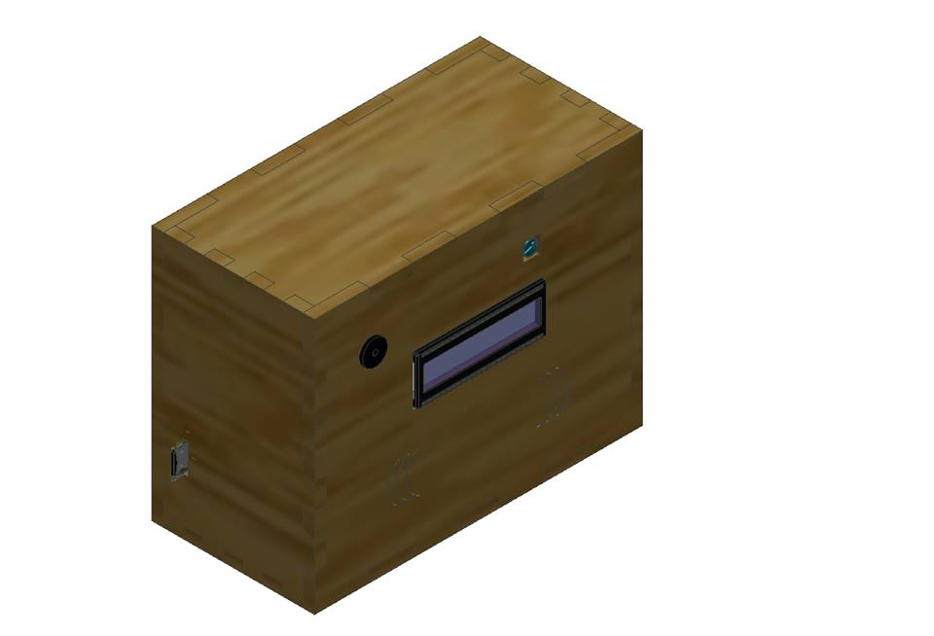
In order to make the mounted equipment secure to external factors and violations, it will be placed into a plywood box. The box can be placed next to the professor table, or in a wall, providing better control of the swiped cards in class and easily access to the information in it.
The design of the box consists of a plywood versatile rectangle, 3.7’’ length x 5.26’’ width x 5.5’’ height. There is a small opening where the MicroSD card can be removed. One of the sides of the box is removable so that the battery can be easily replaced. The box was cut using a laser cutter, having as raw material a plywood sheet of dimensions 18’’ x 22’’ x ¼’’. The dimensions and shape of the box were designed using Autodesk Inventor.
The box will have another opening where the LCD screen will be placed and another one for the Piezo Buzzer. In addition there will be a sign on the box indicating where cards are supposed to be swiped, to make students swipe their cards as close to the RFID reader as possible.

INSTRUCTION MANUAL
Here we will describe how a professor can use our device to automate the check-in process and control the attendance information.

Complete the excel file
The professor should write an excel (.csv) file like the following and save it inside the MicroSD card. The card should be then placed in the slot provided in the wood box.

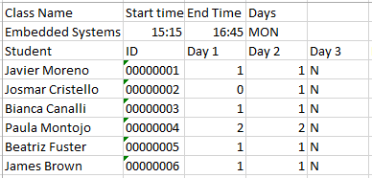

There are a few important fields that must be filled out in this file. All of them can be either paramenters about the students or parameters about the class.
Among the parameters about the class, the professor has to specify its name, start time, end time, and the days of the week in which the class is given (for example, MON for Monday). The parameters about the students are the students’ names and IDs, and an attendance matrix. This matrix will be explained in the following paragraphs.

Attendance Matrix
The Attendance Matrix stores one character for each student each day the class is given. This character will contain information about the students’ attendance, and it can only have 4 values:

0 – The student was absent
Absence is considered when a student hasn’t swiped his card during the time the class is given. The device considers that the class is being given from fifteen minutes before the start time to fifteen minutes after the end time.

1 – The student attended class on time
Attending on time is considered when the student arrives earlier than 15 minutes after the beginning of the class.

2 – The student attended class late
Attending late is considered when the student arrives later than fifteen minutes after the beginning of the class.

N – Future day (no data available)
An ‘N’ corresponds to a future day in which the class will be given. Hence there is no data about the student’s attendance in this case.
Therefore, when the professor sets up the excel file at the beginning of the semester, he should set every character in the matrix to ‘N’. After the class starts and students start coming to class, the matrix will be filled automatically with either 0, 1 or 2.

Let students swipe their cards
The professor can place the box over his table and students must swipe their ID cards as they arrive to class. Then our device will modify the excel file taking into account the student’s ID (which is written on the card) and the time in which they arrived (given by the Real Time Clock). The screen and the buzzer will react differently when the card is swiped (see 2.5 and 2.6).
However, Arduino won’t see the .csv file as a table, but as a set of values separated with commas:

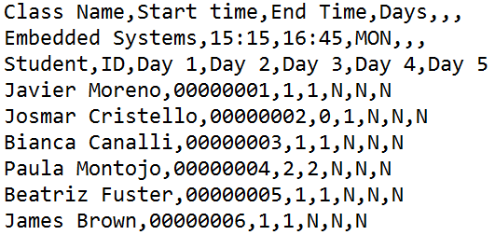

Arduino will manage these data using a multidimensional array which represents the table.

Check student’s attendance
Whenever he/she wants, the professor can check the data about student’s attendance simply taking the MicroSD card from our device and reading it using his computer. He will be able anytime to read and/or write data on the table.

DEVICE CODE
Source code is available in the attached file with this paper.

BUSINESS PROTOTYPE
Here we are going to explain the reasons why we’ve chosen our key components and the possibilities they bring. We’ll also analyze the cost of our finished prototype.

Why RFID and MicroSD?

RFID vs. Magnetic Sripe Card
One of the first decisions to be made while starting this project was which type of cards we should use for our system. After doing some research, we concluded that there are three fields which we can use to compare both card formats: compatibility, price and security. Analyzing these fields is the key to select the optimum type of card.

Compatibility
Whereas there are more than one RFID reader circuitboards available to be used with Arduino, there is not a Magnetic Stripe Card module that has the same compatibility. Hence choosing an RFID card reader would make it easier to assemble both components (reader and Arduino) in one single device.
Furthermore we could easily find an RFID card reader/writer which was useful to write the student’s IDs on each card to test our prototype. We had much more difficulties to find an available Magnetic Stripe Card writer.

Price
The compatible RFID module we found was $39.95 in Adafruit shop. This may be more expensive than certain Magnetic Stripe modules, but in this case the compatibility problem appears and makes it worth to buy a more expensive card reader.

Security
Several sources indicate that and RFID card based system is more secure than a Magnetic Stripe card one. According to Infosecurity Magazine, RFID readers are designed so that they only read the necessary fields of a card, whereas by swiping a Magnetic Card on a reader all the information in the magnetic stripe is read. This way some confidential information might be read and the system would be less secure.

MicroSD
MicroSD cards are one of the most common memory cards used in smart devices these days. The advantages versus regular SD cards is their size, while the cost is slightly similar. We decided to use a MicroSD for compatibility reasons, as Adafruit shop provided a cheap module which can be easily connected to Arduino. Besides, there is a library with functions that make the module easy to use.

Device costs
The calculation of the cost of our prototype was done taking into account the costs of each element we used for both the circuitry and the wood box. All electronic components’ prices are available online in http://www.adafruit.com/.
- Arduino Mega - $45.95
- LCD Screen - $13.95
- RFID card reader/writer shield - $39.95
- MicroSD card breakout board - $14.95
- MicroSD card (4GB) - $7.95
- Real Time Clock breakout board kit - $9.00
- Piezo buzzer - $1.50
- Rest of boards/wires - $5.00
- Plywood sheet - $8.00
- TOTAL – $146.25

REFERENCES
- McGraw-Hill. Nov 8, 2011. Programming Arduino Getting Started with Sketches.
- Malmö University. April 5, 2013. Arduino FAQ – With David Cuartielles".
- Sing, Jay; Brar, Navjit; Fong, Carmen. 2013. The State of RFID Applications in Libraries. Information Technology and Libraries. 25–32
- Bill Glover, Himanshu Bhatt. 2006. RFID essentials. Pages 88-89
- Ala-Paavola, Jaakko. Jan 16, 2000. Software interrupt based real time clock source code project for PIC microcontroller.
- MIT Electric Vehicle Team. Dec, 2008. A Guide to Understanding Battery Specifications

